Configuration and CLI Command

**Step 1 Configure all device based on table configuration, dont forget rename all router according to their location.**

* 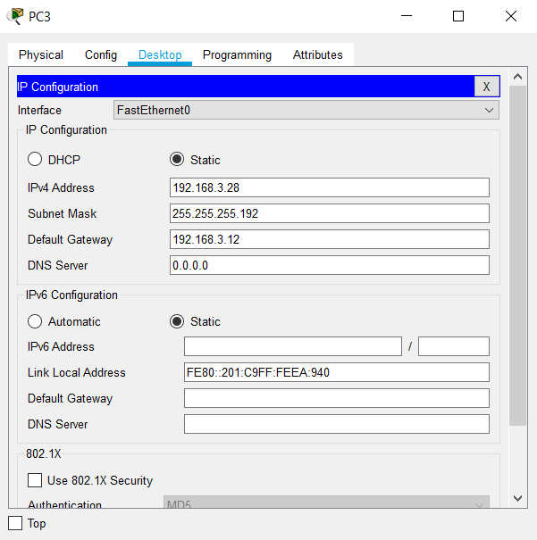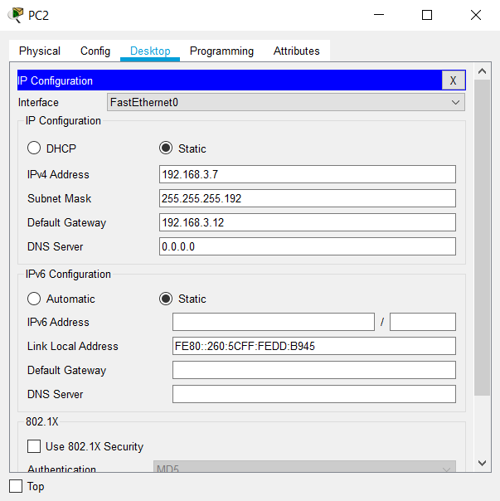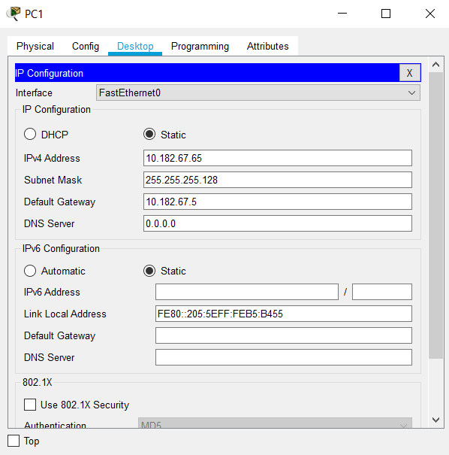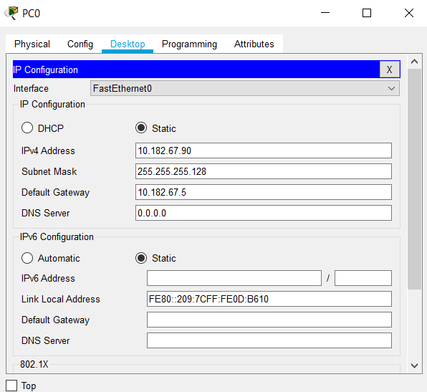PC

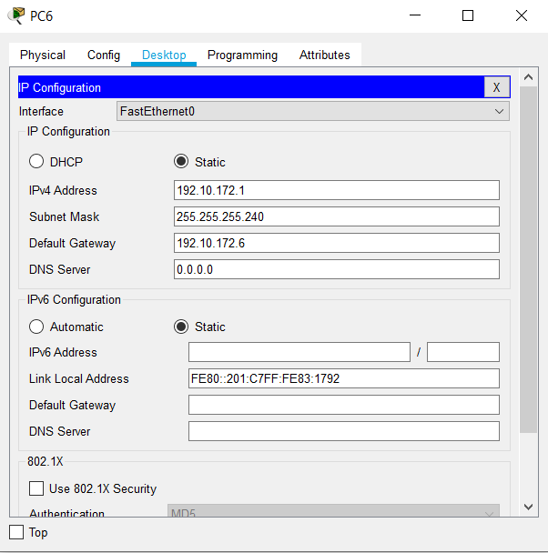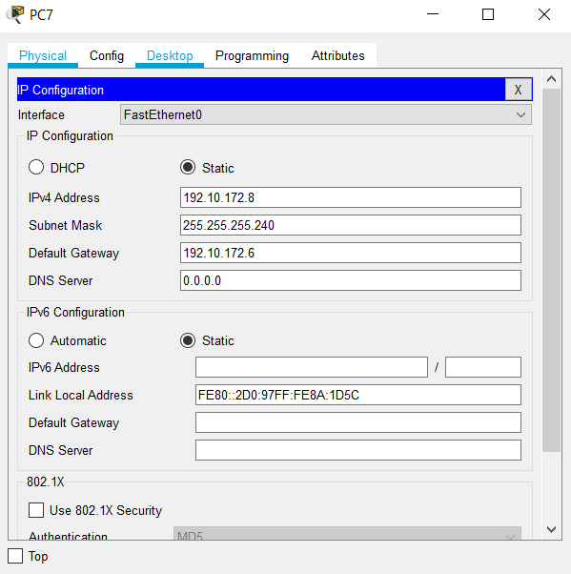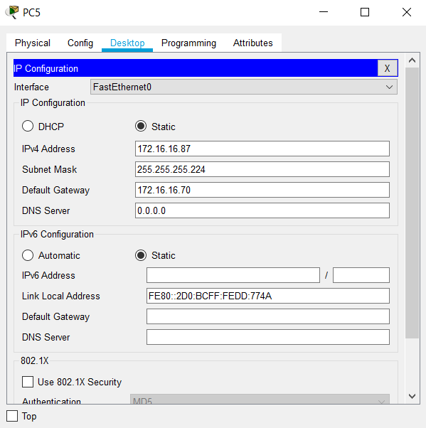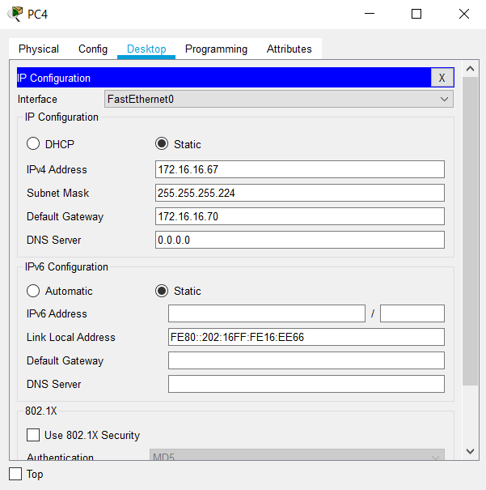

* Router0 – Router3

#Router>enable

Router#configure terminal

Router (config)#interface fa0/0

Router (config-if) #ip address 10.182.67.5 255.255.255.128

Router(config-if) #no shutdown

Router(config-if) #exit

Router(config) #interface se2/0

Router (config-if) #ip address 198.74.99.33 255.255.255.252

Router(config-if) #no shutdown

Router(config-if) #exit

Router(config) #interface se3/0

Router (config-if) #ip address 100.252.175.45 255.255.255.248

Router(config-if) #no shutdown

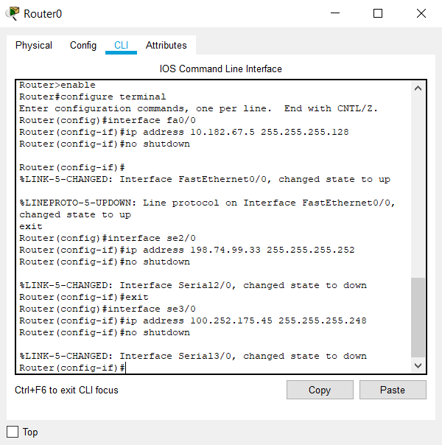**Screenshot :**

#Router>enable

Router#configure terminal

Router (config)#interface fa0/0

Router (config-if) #ip address 192.168.3.12 255.255.255.192

Router(config-if) #no shutdown

Router(config-if) #exit

Router(config) #interface se3/0

Router (config-if) #ip address 198.74.99.34 255.255.255.252

Router(config-if) #no shutdown

Router(config-if) #exit

Router(config) #interface se2/0

Router (config-if) #ip address 65.195.160.21 255.255.255.252

Router(config-if) #no shutdown

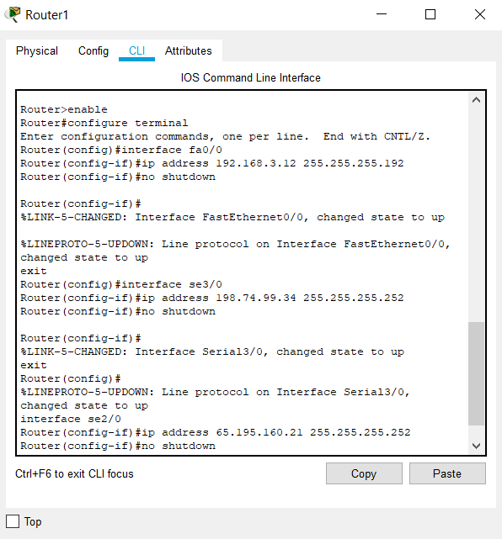**Screenshot :**

#Router>enable

Router#configure terminal

Router (config)#interface fa0/0

Router (config-if) #ip address 172.16.16.70 255.255.255.224

Router(config-if) #no shutdown

Router(config-if) #exit

Router(config) #interface se3/0

Router (config-if) #ip address 65.195.160.22 255.255.255.252

Router(config-if) #no shutdown

Router(config-if) #exit

Router(config) #interface se2/0

Router (config-if) #ip address 45.199.23.135 255.255.255.224

Router(config-if) #no shutdown

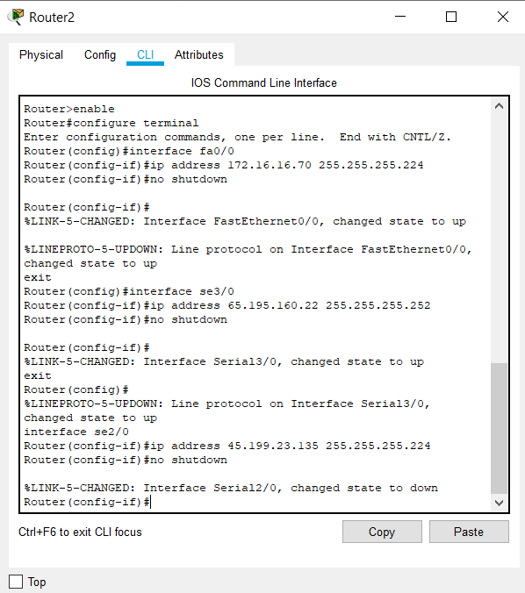**Screenshot :**

#Router>enable

Router#configure terminal

Router (config)#interface fa0/0

Router (config-if) #ip address 192.10.172.6 255.255.255.240

Router(config-if) #no shutdown

Router(config-if) #exit

Router(config) #interface se3/0

Router (config-if) #ip address 45.199.23.149 255.255.255.224

Router(config-if) #no shutdown

Router(config-if) #exit

Router(config) #interface se2/0

Router (config-if) #ip address 100.252.175.43 255.255.255.248

Router(config-if) #no shutdown

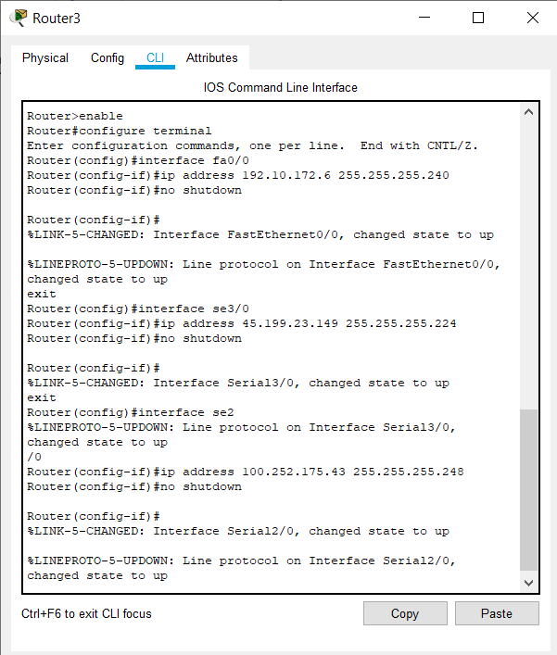**Screenshot :**

**Step 2 Give nick name on each device with 3 digit your name**

* 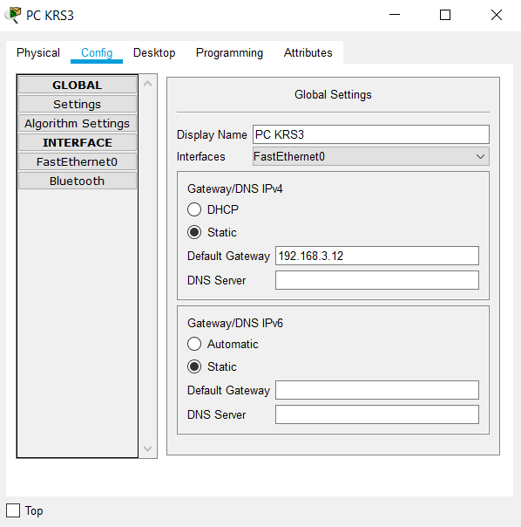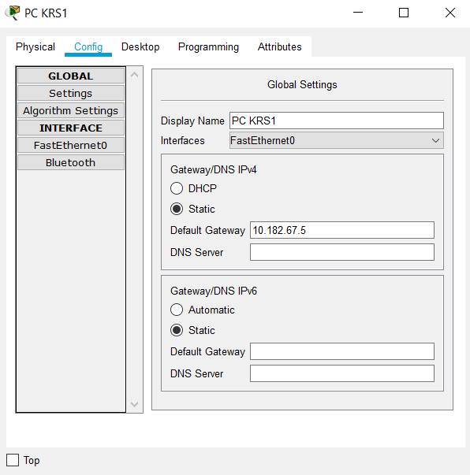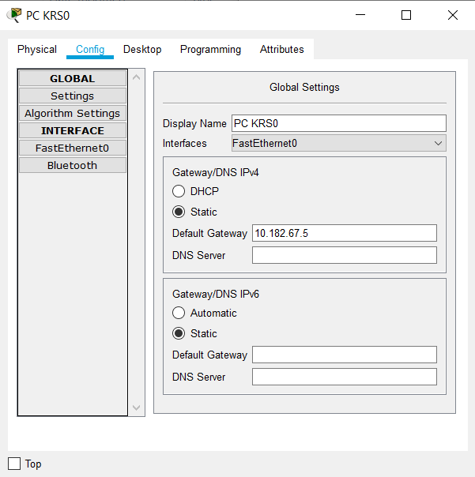PC

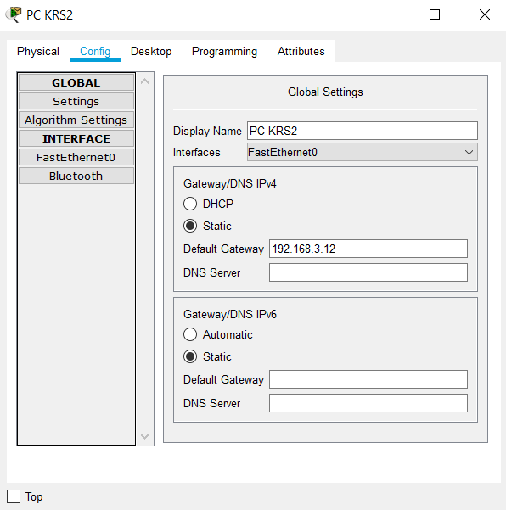

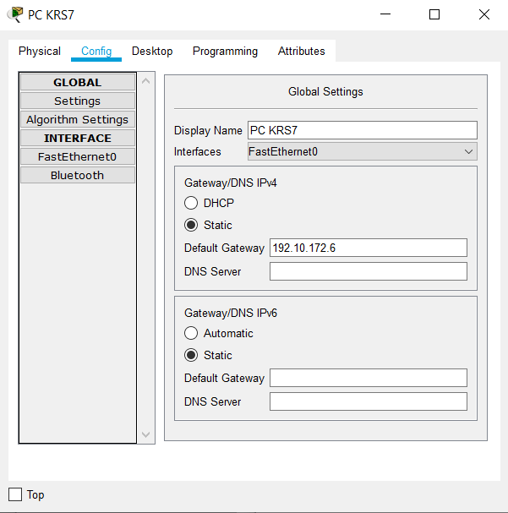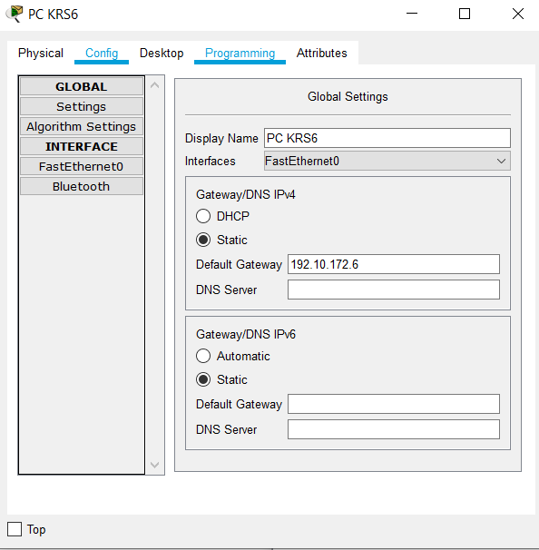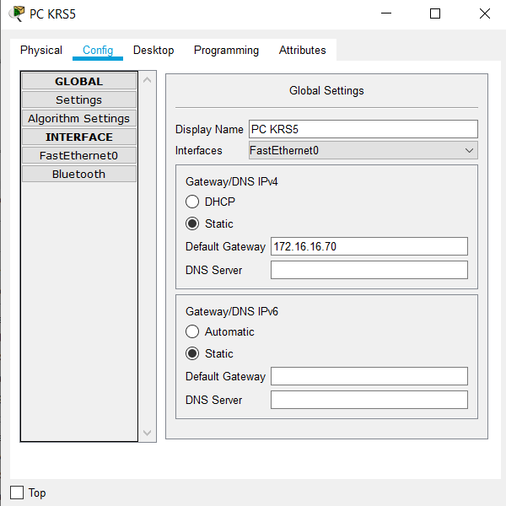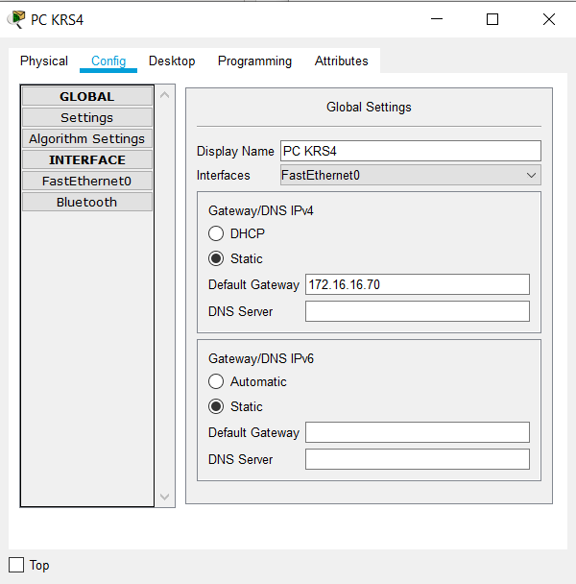

* **Rename Switch**

Switch>enable

Switch#configure terminal

Switch (config) #hostname SKRS0

Switch>enable

Switch#configure terminal

Switch (config) #hostname SKRS1

Switch>enable

Switch#configure terminal

Switch (config) #hostname SKRS2

Switch>enable

Switch#configure terminal

Switch (config) #hostname SKRS3

* **Rename Router**

Router>enable

Router#configure terminal

Router (config) #hostname RKRS0

Router>enable

Router#configure terminal

Router (config) #hostname RKRS1

Router>enable

Router#configure terminal

Router (config) #hostname RKRS2

Router>enable

Router#configure terminal

Router (config) #hostname RKRS3

**Step 3 Configure ALL router with routing OSPF to provide routing for all PC**

RKRS0 >enable

RKRS0 #configure terminal

RKRS0 (config) #router ospf 1

RKRS0 (config-router) #router-id 1.1.1.1

RKRS0 (config-router) #do show ip route connected

RKRS0 (config-router) #network 10.182.67.0 0.0.0.127 area 0

RKRS0 (config-router) #network 100.252.175.40 0.0.0.7 area 1

RKRS0 (config-router) #network 198.74.99.32 0.0.0.3 area 0

RKRS0 (config-router) #passive-interface fa0/0

RKRS0 (config-router) #exit

RKRS0 (config) #exit

RKRS0 #copy running-config startup-config

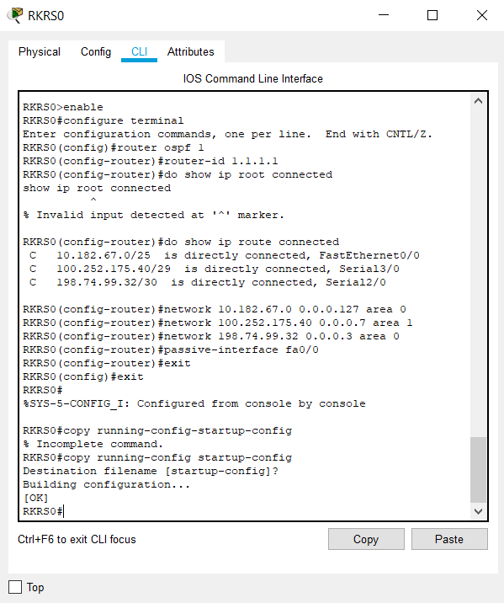**Screenshot :**

RKRS1 >enable

RKRS1 #configure terminal

RKRS1 (config) #router ospf 1

RKRS1 (config-router) #router-id 2.2.2.2

RKRS1 (config-router) #do show ip route connected

RKRS1 (config-router) #network 65.195.160.20 0.0.0.3 area 1

RKRS1 (config-router) #network 192.168.3.0 0.0.0.63 area 0

RKRS1 (config-router) #network 198.74.99.32 0.0.0.3 area 0

RKRS1 (config-router) #passive-interface fa0/0

RKRS1 (config-router) #exit

RKRS1 (config) #exit

RKRS1 #copy running-config startup-config

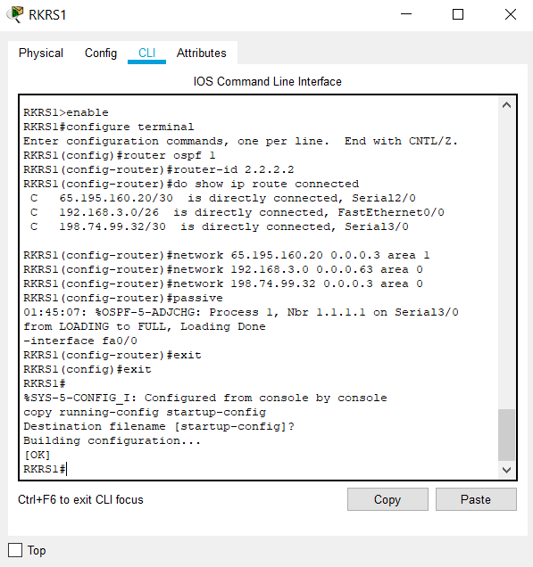**Screenshot :**

RKRS2 >enable

RKRS2 #configure terminal

RKRS2 (config) #router ospf 1

RKRS2 (config-router) #router-id 3.3.3.3

RKRS2 (config-router) #do show ip route connected

RKRS2 (config-router) #network 45.199.23.128 0.0.0.31 area 1

RKRS2 (config-router) #network 65.195.160.20 0.0.0.3 area 1

RKRS2 (config-router) #network 172.16.16.64 0.0.0.31 area 1

RKRS2 (config-router) #passive-interface fa0/0

RKRS2 (config-router) #exit

RKRS2 (config) #exit

RKRS2 #copy running-config startup-config

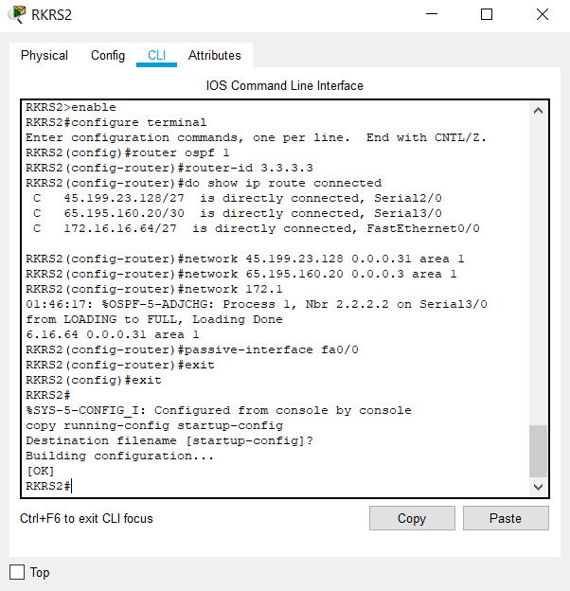**Screenshot :**

RKRS3 >enable

RKRS3 #configure terminal

RKRS3 (config) #router ospf 1

RKRS3 (config-router) #router-id 4.4.4.4

RKRS3 (config-router) #do show ip route connected

RKRS3 (config-router) #network 45.199.23.128 0.0.0.31 area 1

RKRS3 (config-router) #network 100.252.175.40 0.0.0.7 area 1

RKRS3 (config-router) #network 192.10.172.0 0.0.0.15 area 1

RKRS3 (config-router) #passive-interface fa0/0

RKRS3 (config-router) #exit

RKRS3 (config) #exit

RKRS3 #copy running-config startup-config

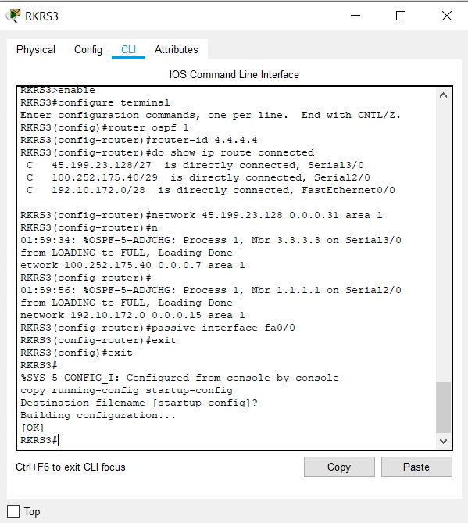**Screenshot :**

**Step 4 Verify routing table with print all routing table on each router**

RKRS0 >enable

RKRS0 #show ip route

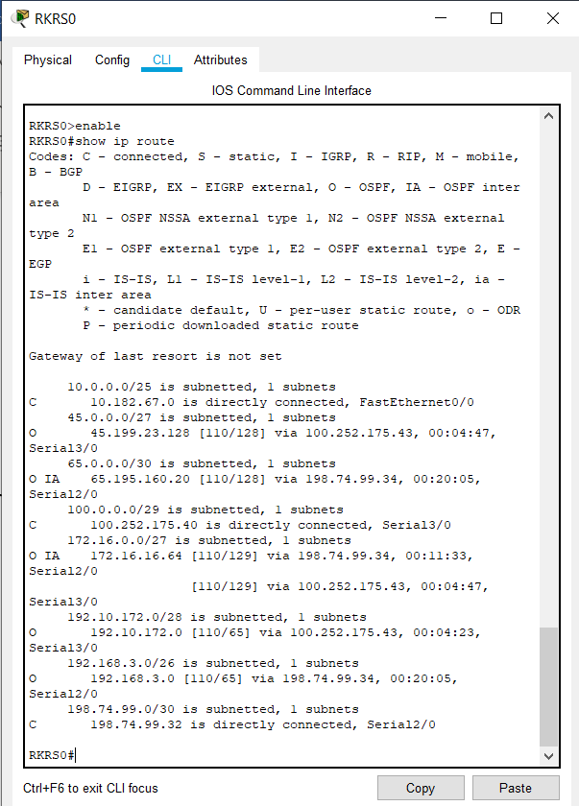**Screenshot :**

RKRS1 >enable

RKRS1 #show ip route

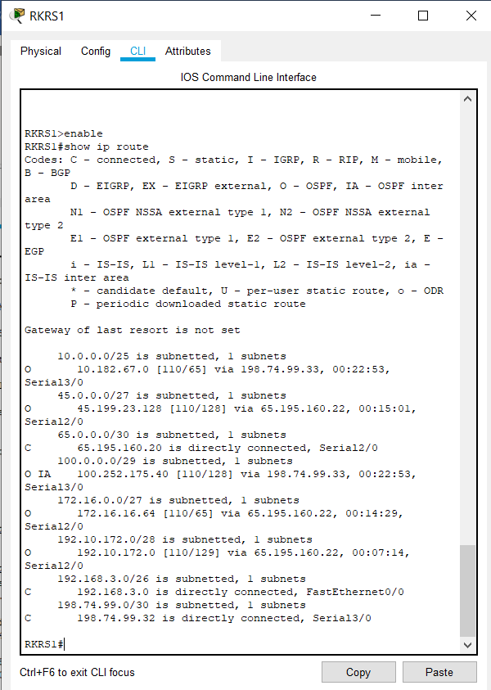**Screenshot :**

RKRS2 >enable

RKRS2 #show ip route

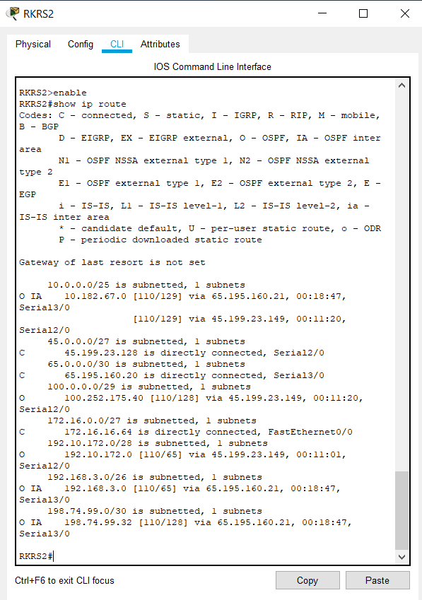**Screenshot :**

RKRS3 >enable

RKRS3 #show ip route

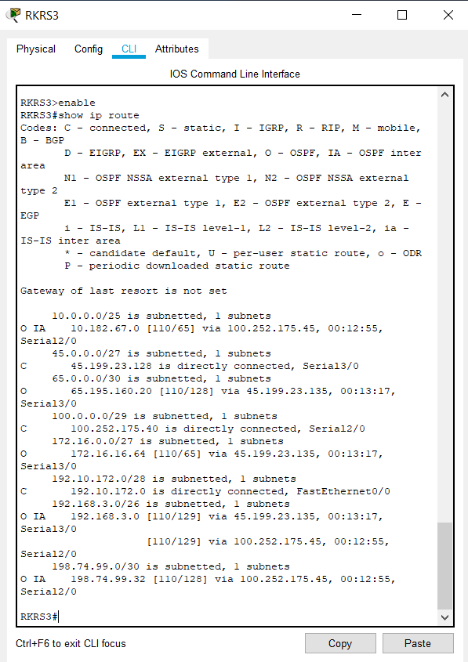**Screenshot :**

**Step 5 Run command show run on each router**

RKRS0 >enable

RKRS0 #show run

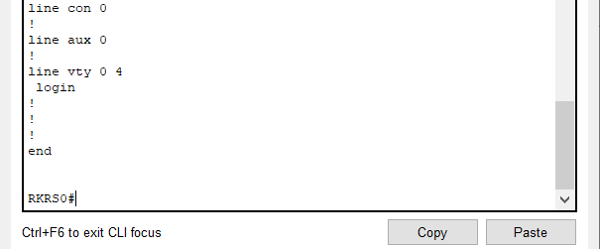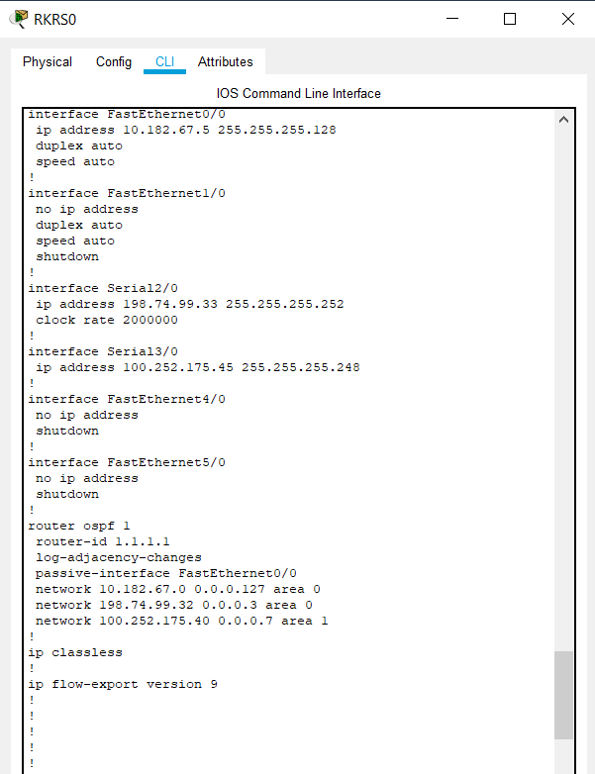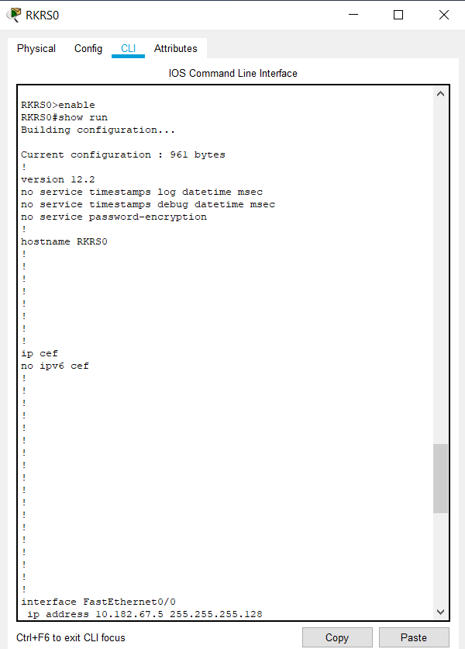**Screenshot :**

RKRS1 >enable

RKRS1 #show run

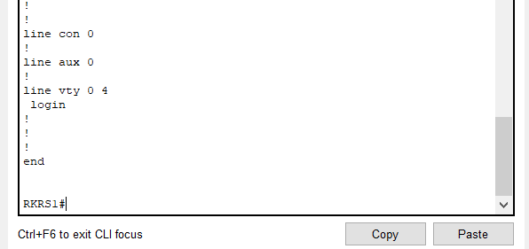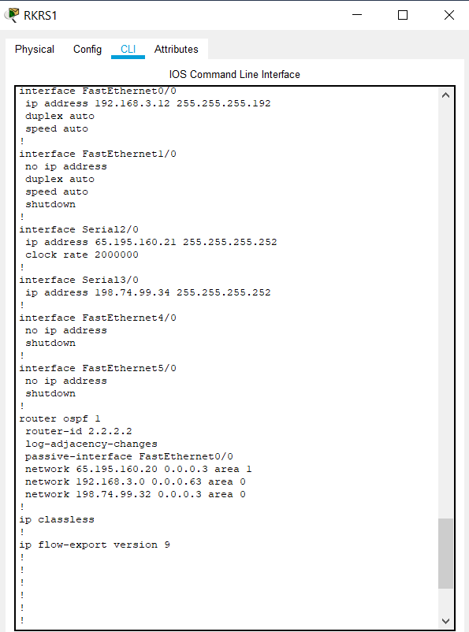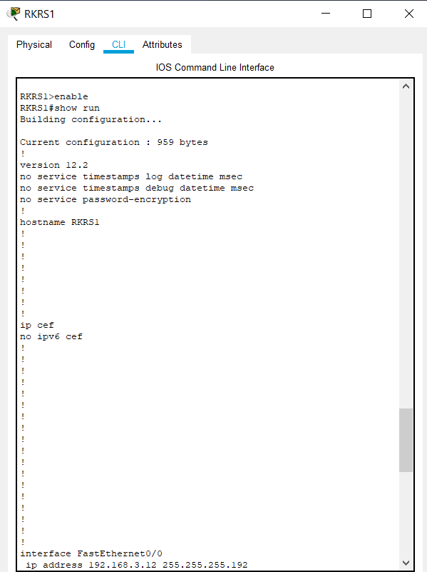**Screenshot :**

RKRS2 >enable

RKRS2 #show run

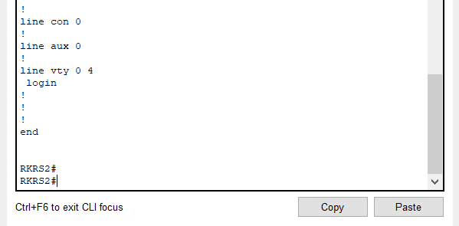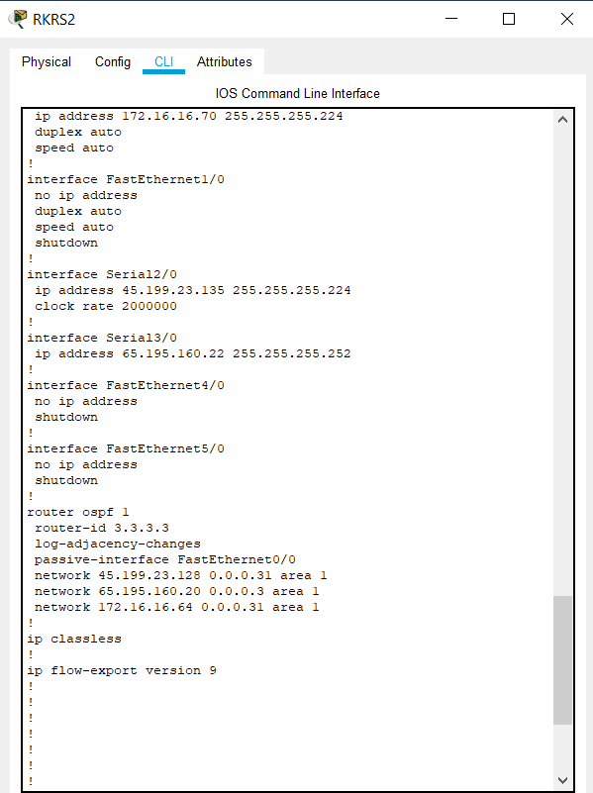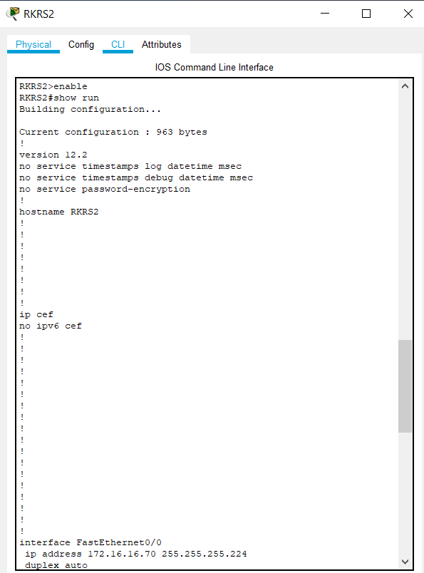**Screenshot :**

RKRS3 >enable

RKRS3 #show run

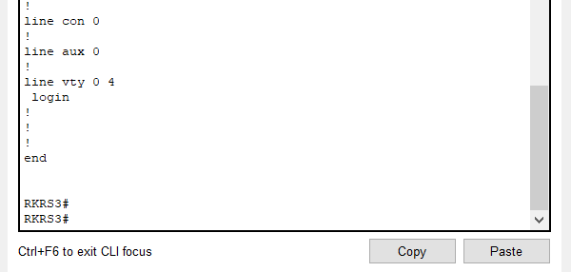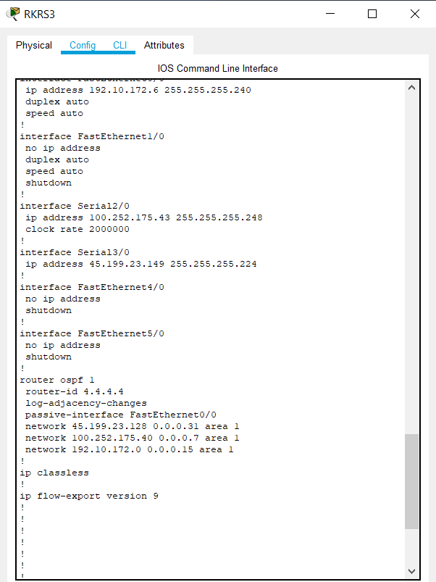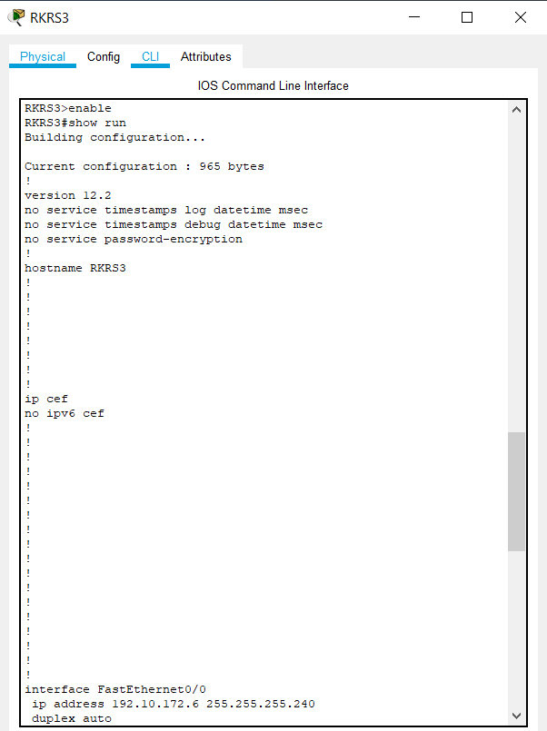**Screenshot :**